Digital Image Processing

CE-38-B

MISHAAL SAFEER

SAMEEN ABBAS

FOHA KHALID

MUHAMMAD HASHIR SHOAIB

2019

# Task 1

## Q:

Create a distance map of 480 rows and 640 columns as shown below, The image has 0 at the corners and 255 at the middle.

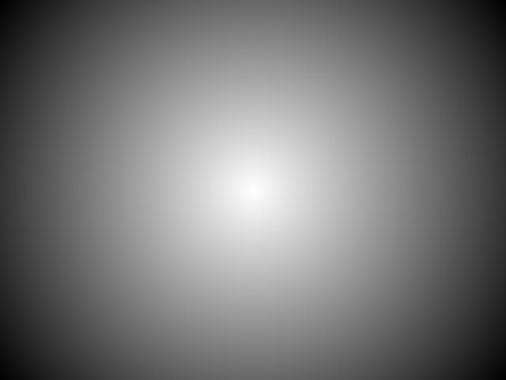

P (i, j) =255 – (r / c * 255)

Where: c = distance between location (0, 0) and center of image.

r = distance between pixel location and center of image.

## Algorithm:

def circularFilter(row, col):  
 ciPic = np.zeros((row, col))  
 rowCentre = row / 2  
 colCentre = col / 2  
 c = m.sqrt((0 - rowCentre) * (0 - rowCentre) + (0 - colCentre) * (0 - colCentre))  
 for i in range(0, row):  
 for j in range(0, col):  
 r = m.sqrt((i - rowCentre) * (i - rowCentre) + (j - colCentre) * (j - colCentre))  
 ciPic[i][j] = int(255 - (r / c * 255))  
 return ciPic  
  
  
cv.imwrite(**"circleFilter.png"**, circularFilter(480, 640))

## Output:

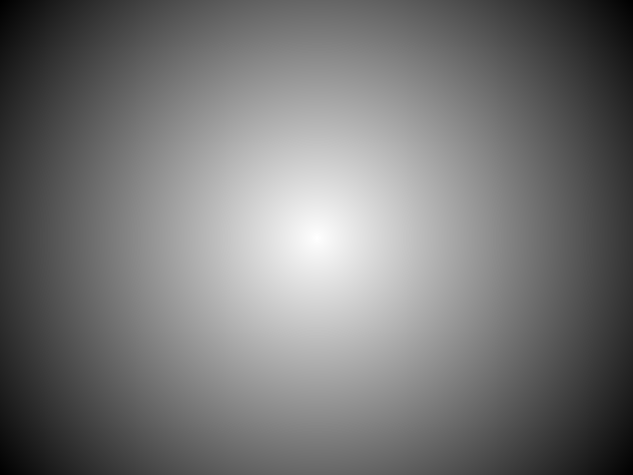

Figure 1: circleFilter.png

# Tack 2

## Q:

Multiply the image obtained in Task 1 with image of the balloon. Take necessary measures for data types and ranges.

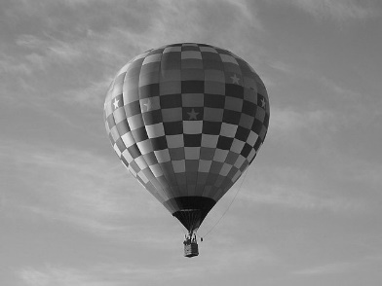 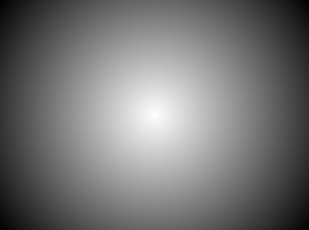 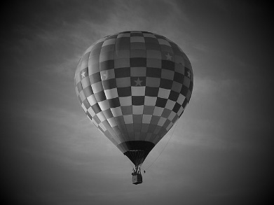

X =

## Algorithm:

def mapRange(s):  
 a1, a2, b1, b2 = 0, 200 * 267, 0, 255  
 return b1 + ((s - a1) * (b2 - b1) / (a2 - a1))  
  
  
balArray = cv.imread(**"./Picture1.png"**, 0)  
brow, bcol = np.shape(balArray)  
temparray = circularFilter(brow, bcol)  
new1array = np.zeros((brow, bcol))  
for i in range(0, brow):  
 for j in range(0, bcol):  
 new1array[i][j] = int(mapRange(temparray[i][j] * balArray[i][j]))  
cv.imwrite(**"filteredPic.png"**, new1array)  
print(new1array)

## Output:

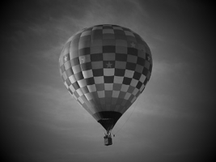

Figure 2: filteredPic.png

# Task 3

## Q:

Write a code that take theta from the user and draw a rectangle in that direction as shown. The size of the image should be 500 x 500, origin of the angle is at location (i, j) = (450, 50) and, length and width of rectangle is equal to 400 and 20 pixels respectively. Description is on the next page.

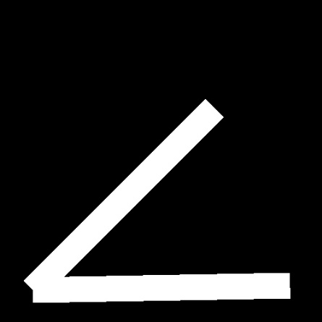 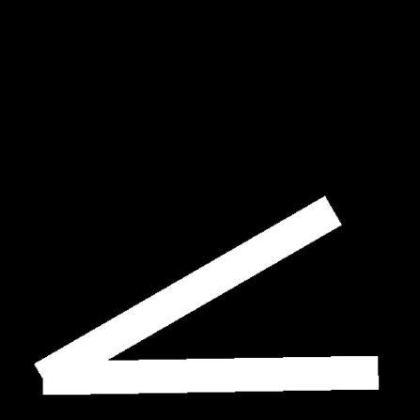 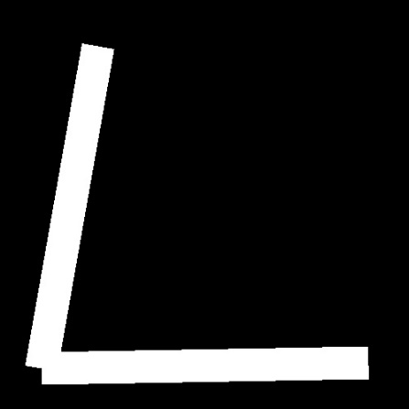

## Algorithm:

angleImage = np.zeros((500, 500))  
  
  
def makeRectangleinWhite(angleinRadian, Image):  
 x, y = [450, 50]  
 t = angleinRadian  
 l, w = [400, 20]  
 ax = int(x + (w * m.cos(t)))  
 ay = int(y + (w * m.sin(t)))  
 bx = int(x - (w * m.cos(t)))  
 by = int(y - (w * m.sin(t)))  
 px = int(x - (l * m.sin(t)))  
 py = int(y + (l * m.cos(t)))  
 cx = int(px + (w * m.cos(t)))  
 cy = int(py + (w * m.sin(t)))  
 dx = int(px - (w * m.cos(t)))  
 dy = int(py - (w * m.sin(t)))  
 for i in range(0, 500):  
 for j in range(0, 500):  
 if j < ((i-ax)/m.tan(-t))+ay and j > ((i-bx)/m.tan(-t))+by and j > ((i-ax)*m.tan(t))+ay and j < ((i-cx)*m.tan(t))+cy:  
 Image[i][j] = 255  
 return Image  
  
  
angleImage = makeRectangleinWhite(0.57, angleImage)  
angleImage = makeRectangleinWhite(0.0001, angleImage)  
cv.imwrite(**"angleImage.png"**, angleImage)

## Output:

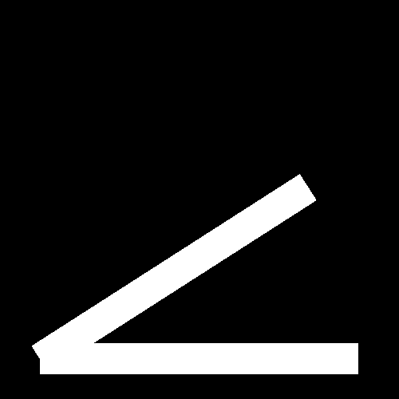

Figure 3: angleImage.png